Robot v1.25

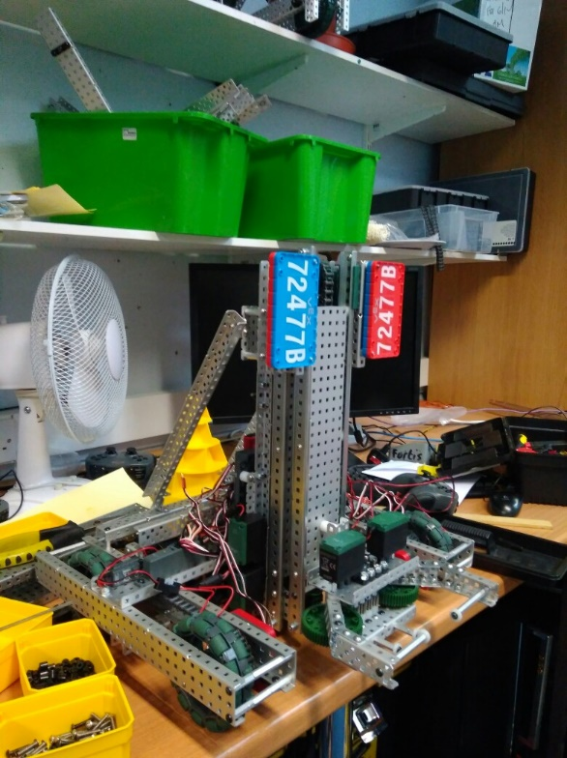

**Specification:**

* 6 Motor HS drive
* 2 drive chains
* 4 wheels
* Aluminium structure
* 4 motor lift
* 3 stage lift
* 2 motor claw

**Dimensions:**

* 17.5” x 15” x 17.5” when not extended

Logged by Sam Poirier

19/07/2017 – 17:06

**Overview:**

Most of the time spent this session was focused on trying to fix the chain skipping problem which we finally fixed. For more details on the problem have a look at the 2nd problem document on page (###). Along with fixing that major problem we also experimented with adding two support struts behind the lift to give it greater stability. They turned out to be quite useful so we have made them part of the key structure. We also located a place to initially mount the number plates. It is important that it is easy to swap out the colours for when we enter a competition. The place they currently reside looks nice however is not very practical as it only shows the robots number from a single direction so we will need to move them to opposing sides of the robot.

**Future Changes:**

* Plug in shaft encoders
* Cable manages
* Put number plates in a better position

**Changes Made:**

* Fixed chain skipping problem
* Added number plates
* Added two support bars